INTERNET MARKETING SOLUTIONS

GUIDE





**By**

**Manfred Liechti**

[](https://www.bluehost.com/track/fredlic/)**Webhosting**

[Bluehost](https://www.bluehost.com/track/fredlic/)

[](https://www.bluehost.com/track/fredlic/)[](https://www.bluehost.com/?utm_source=%28direct%29&utm_medium=affiliate&utm_campaign=affiliate-link_fredlic_notype)Website piece of mind from your trusted hosting partner! Starting at $2.95/month!

[Bluehost](https://www.bluehost.com/track/fredlic/) is a web hosting company owned by Endurance International Group. It is one of the 20 largest web hosts, collectively hosting well over 2 million domains. The company operates its servers in-house in a 50,000 square feet facility in Provo, Utah. Bluehost employs over 750 people in its Utah facility. Recommended by WordPress®.

[Bluehost](http://www.bluehost.com/) offers three plans: basic, plus and choice plus (which is their recommended plan).

[Website:](https://www.bluehost.com/track/fredlic/)

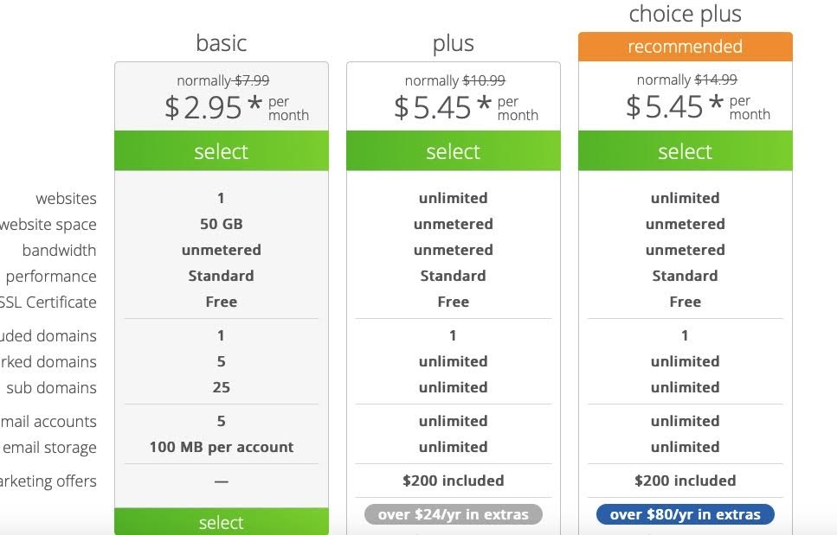

Updated on: 14 April 2020

Bluehost is hosting various of our websites, most notably our group website [www.infodigitalgroup.com](http://www.infodigitalgroup.com)

**[](http://www.namecheap.com/)**

**[](http://www.namecheap.com/)Webhosting/Domains**

[**Namecheap**](http://www.namecheap.com/)

Namecheap is a provider of ICANN-accredited domain registration and web hosting service.  
  
[Namecheap'](http://www.namecheap.com/)s headquarters is located in Los Angeles, California. Namecheap generates $164.7K in revenue per employee Namecheap's top competitor is OnlyDomains, led by Desleigh Jameson, who is their CEO. Namecheap has 746 followers on [Owler](https://www.owler.com/company/namecheap).

Annual revenue: US$ 123.5 million

Employees: 7540

Sector: IT Services

C0-Founder & CEO: Richard Kirkendall

Owler CEO Approval Ranking:68/100

Fouded: 2000 in los Angeles/California

Private Company

Namecheap features three categories of webhosting plan: beginners, Small Businesses and Large Businesses.

[Website](http://www.namecheap.com/)

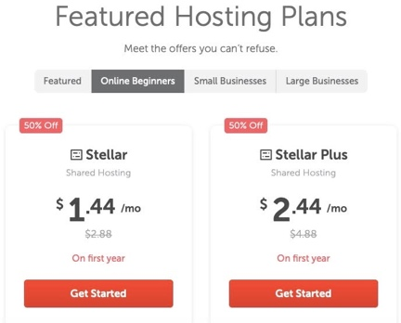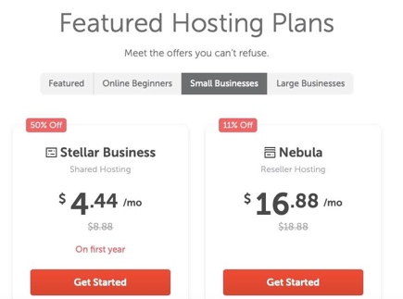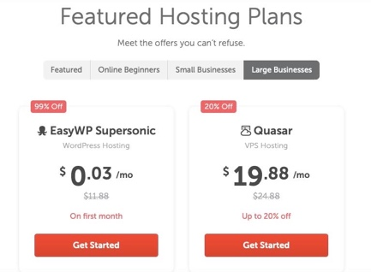

**[](http://www.godaddy.com/)Webhosting/Domains**

[**GoDaddy**](http://www.godaddy.com/)

[GoDaddy](http://www.godaddy.com/) is an internet domain registration company that offers website hosting, online marketing and security services for individuals and businesses.  
  
GoDaddy is a Public company. GoDaddy's IPO date was on Mar 2015. Aman Bhutani is the CEO of GoDaddy and has an approval rating of 69 from Owler members. GoDaddy has raised a total of $460M in funding. GoDaddy's most recent acquisition was Over, Inc. for an undisclosed amount on Jan 2020. GoDaddy has 7,990 followers on [Owler](https://www.owler.com/company/godaddy).

Annual revenue: US$ 3 billion

Employees: 6821

Sector: IT Services

C0-Founder & CEO: Aman Bhutani

Owler CEO Approval Ranking:69/100

Fouded: 1997 in Scottsdale/Arizona

Ticker: GDDY

Bourse: NYSE

Website: [www.godaddy.com](http://www.godaddy.com)

[](http://www.wix.com/)**Website Builder**

[](http://www.wix.com/)

[**Wix**](http://www.wix.com/)

[Wix.com](http://www.wix.com/) is a cloud-based web development platform that allows users to create HTML5 websites and mobile sites through online drag and drop tools.  
  
Wix's headquarters is in Tel Aviv, Tel Aviv District. Wix has a revenue of $727.8M, and 1,067 employees. Wix's IPO generated $127M. Wix's main competitors are Squarespace, Weebly and Jimdo. As of February 2020, Wix has 4.3M fans on Facebook and 396.0K followers on Twitter.

Annual revenue: US$ 727.8 million

Employees: 1067

Sector: Internet Software

C0-Founder & CEO: Avishai Abrahami

Owler CEO Approval Ranking:73/100

Fouded: 2006 in Tel Aviv/Israel

Ticker: WIX

Bourse: NSASDAQ

Top competitors:

1. [Squarespace](http://www.squarespace.com/)
2. [Weebly](http://www.weebly.com/)
3. [Jimo](http://www.jimdo.com/)
4. [Shopify](http://www.shopify.com/)
5. [Strikingly](http://www.strikingly.com/)

It seems quite obvious that the developers at [Wix](http://www.wix.com/) built its capabiltes with the end client as priority in mid. The powerful drag and drop functionality is very easy to use and very client centric. Building good websites has never been easier!

Website: [www.wix.com](http://www.wix.com)

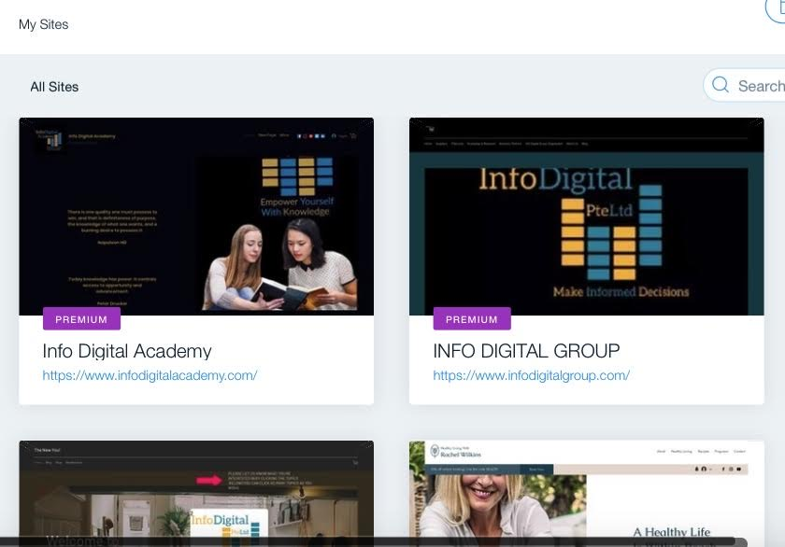

We used Wix to build our websites

[www.infodigitalgroup.com](http://www.infodigitalgroup.com), [www.ibfodigitalacademy.com](http://www.ibfodigitalacademy.com) and [www.revampedyou.com](http://www.revampedyou.com).



Wix is the preferred Website Builder of Info Digital Group.

**[](http://www.bookmark.com/)Website Builder**

[**Bookmark**](http://www.bookmark.com/)

[Bookmark](http://www.bookmark.com/) is a drag and drop cloud-based website development platform. Bookmark is a Private company. David Kosmayer is the Founder & CEO of Bookmark and has an approval rating of 82 from Owler members. Bookmark's top competitor is [Weebly](https://www.weebly.com/sg?lang=en), led by Dan Veltri, who is their Co-Founder. Bookmark has 428 followers on [Owler](https://www.owler.com/company/bookmark)

Annual revenue: US$ 9.4 million

Employees: 40

Sector: Application Software

Founder & CEO: David Kosmayer

Owler CEO Approval Ranking:92/100

Fouded: 214 in Toronto/Canada

Private Company

Top competitors:

1. [Weebly](http://www.weely.com/)
2. [Squarespace](http://www.squarespace.com/)
3. [Wix](http://www.wix.com/)
4. [Jimdo](http://www.jimdo.com/)
5. [Shopify](http://www.shopify.com/)

Bookmark’s drag and drop functionality is easy to use and supported by AI.



[Bookmark](http://www.nookmar.con/) offer three pricing plans: Business (e-commerce/Online stores), Professional (Small Business/Entrepreneurs) and Free (basic use):

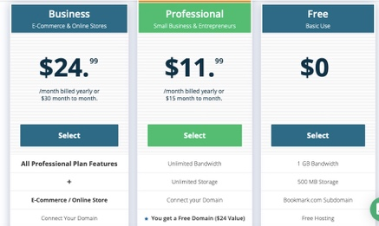

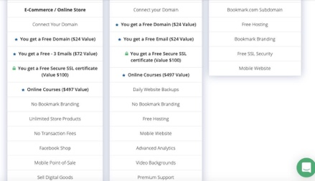

Info Digital Group used Bookmark to build its website [www.bettersleepasia.com](http://www.bettersleepasia.com) and several private websites of Manfred Liechti.

**[](http://www.webex.com/)Video Streaming**

[**Cisco Webex**](http://www.webex.com/)

[WebEx](http://www.webex.com/) provides on-demand collaboration, online meeting, web conferencing and video conferencing applications.  
  
WebEx is a Private company. WebEx's parent company has been Cisco Systems, Inc. since Feb 2007. WebEx's top competitor is EZTalks, led by Jack Zhang, who is their General Manager. WebEx has 2,846 followers on [Owler](https://www.owler.com/company/webex).

Annual revenue: US$ 465.9 million

Employees: 2,688

Sector: Application Software

Founder & CEO: n.a.

Owler CEO Approval Ranking: n.a.

Fouded: 1995 in Santa Clara/California

Private Company, Subsidiary of Cisco Systems Inc.

Ticker 7372/77374

Bourse: NAICS

Pricing: [Webex](http://www.webex.com/) is offered for free.



[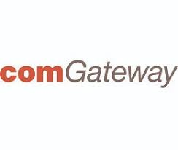](http://www.comgateway.com/)

**Freight Forwarder (International shipping)**

[**comGateway**](http://www.comgateway.com/)

[**comGateway**](http://www.comgateway.com/)

When we order products that Amazon doesn’t ship to Singapore from the US, we use comGateway. Com Gateway provides its clients with a personal shipping address in the US, from where they forward our shipments to our address in Singapore.

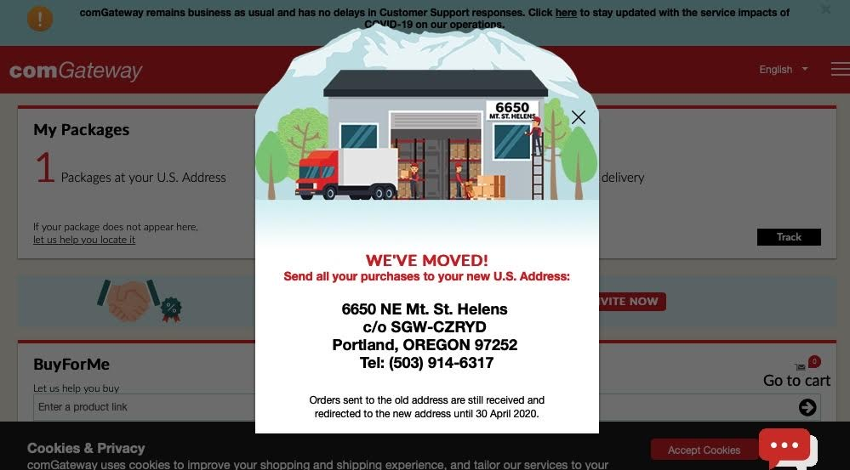

Personal shipping address in the US

How it works?

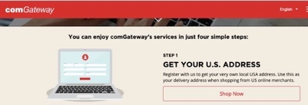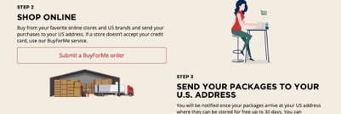



[](http://www.refersion.com/)**Affiliate Program Management**

**[Rsfersion](http://www.refersion.com/)**

[Refersion](http://www.refersion.com/) is a marketing platform that allows online shops track sales driven by promoters, influencers and affiliates.

Annual revenue: US$ 5.8 million

Employees: 3

Sector: Application Software

Founder & CEO: Alex Markov

Owler CEO Approval Ranking: 68/100

Fouded: 2015 in New York/New York

Private Company

Refersion offer two price plans: Professional and Enterprise



Website: [www.refersion.com](http://www.refersion.com)

[](http://www.stripe.com/)**Credit Card Payment Processing**

[Stripe](http://www.stripe.com/)

[Stripe](http://www.stripe.com/) is a web and mobile-based payment processing platform that allows individuals and businesses to accept online payments.

Stripe builds the most powerful and flexible tools for internet commerce. Whether you’re creating a subscription service, an on-demand marketplace, an e-commerce store, or a crowdfunding platform, Stripe’s meticulously designed APIs and unmatched functionality help you create the best possible product for your users. Millions of the world’s most innovative technology companies are scaling faster and more efficiently by building their businesses on Stripe.

Stripe is a Private company. Patrick Collison is the Co-Founder & CEO of Stripe and has an approval rating of 69 from Owler members. Stripe's latest funding round was a Series G for $600M on Apr 2020. Stripe has 11 companies in its portfolio, and its first investment was made in 2018. Stripe has 840,944 followers on [Owler](https://www.owler.com/company/stripe).

Annual revenue: US$ 528 million

Employees: 2500

Sector: Systems Software

C0-Founder & CEO: Patrick Collison

Owler CEO Approval Ranking:69/100

Founded: 2010 in San Frtancisco/California

Private Company

Top competitors:

1. [Square](http://www.squareup.com/)
2. [Adyen](http://www.adyen.com/)
3. [PayPAL](http://www.paypal.com/)
4. [Wepay](http://www.go.wepay.com/)

Stripe offers a one size fits all pricing of 3.4% + 50 Cents.

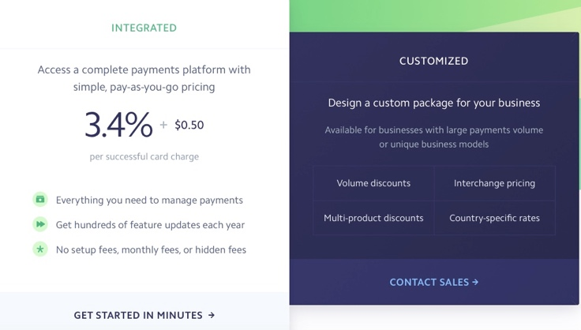

Updated on 14 April 2020

Website: [www.stripe.com](http://www.stripe.com)

**[](http://www.paypal.com/)Payment Processing**

[Paypal](http://www.paypal.com/)

[PayPal](http://www.paypal.com/) is an online payments system to send or receive money or to set up a merchant account.  
  
PayPal is headquartered in San Jose, California. Dan Schulman is the President & CEO of PayPal. PayPal's IPO generated $70.2M. PayPal has 32 companies in its portfolio, including SafeBreach. As of August 2019, PayPal has 6.1M fans on Facebook and 472.6K followers on Twitter.

Website: [www.paypal.com](http://www.paypal.com)

Annual revenue: US$ 17.87 billion

Employees: 21800

Sector: Application Software, Internet Software

CPresident& CEO: Dan Schulman

Owler CEO Approval Ranking:76/100

Founded: 21998 in San Jose/California

Ticker: PYPL

Bourse: NASDAQ

Paypal offers rthe following pricing scbedule:

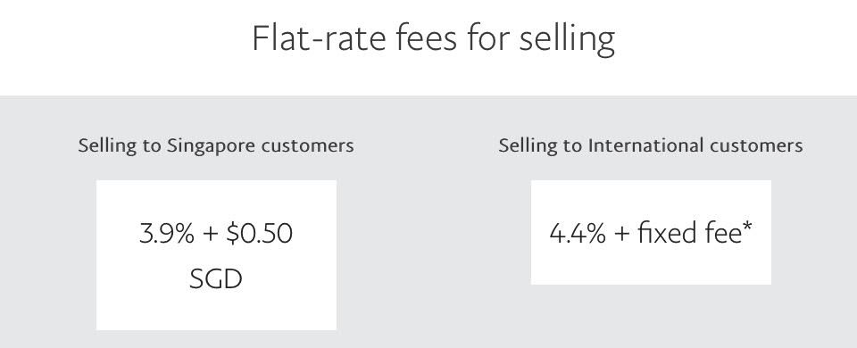

[](http://share.payoneer.com/nav/o50kU_EdP5tbLjqLZHGbo1Dv9Tq4Xltf7PamFTWn9-qUTariX1oIawXJg-qhvksRP2ZRntBSDEZ6beXkHR0UKQ2)

Digital Payment Services

[Payoneer](http://share.payoneer.com/nav/o50kU_EdP5tbLjqLZHGbo1Dv9Tq4Xltf7PamFTWn9-qUTariX1oIawXJg-qhvksRP2ZRntBSDEZ6beXkHR0UKQ2)

[Payoneer](http://share.payoneer.com/nav/o50kU_EdP5tbLjqLZHGbo1Dv9Tq4Xltf7PamFTWn9-qUTariX1oIawXJg-qhvksRP2ZRntBSDEZ6beXkHR0UKQ2) is a financial services company that provides online money transfer and cross-border payment solutions for small and medium-sized businesses.  
  
Payoneer is a Private company. Scott Galit is the CEO of Payoneer and has an approval rating of 79 from Owler members. Payoneer has received a total of $270M in funding. Payoneer's most recent acquisition was Optile GmbH for an undisclosed amount on Dec 2019. Payoneer has 2,897 followers on Owler.

Annual revenue: US$ 174.4 million

Employees 1,500

Sector: Application Software/Psayments

CEO: Scott Galit

Owler CEO Approval Ranking 79/100

Founded: 2005 in New York/New York

Private company

[Website](http://share.payoneer.com/nav/o50kU_EdP5tbLjqLZHGbo1Dv9Tq4Xltf7PamFTWn9-qUTariX1oIawXJg-qhvksRP2ZRntBSDEZ6beXkHR0UKQ2)

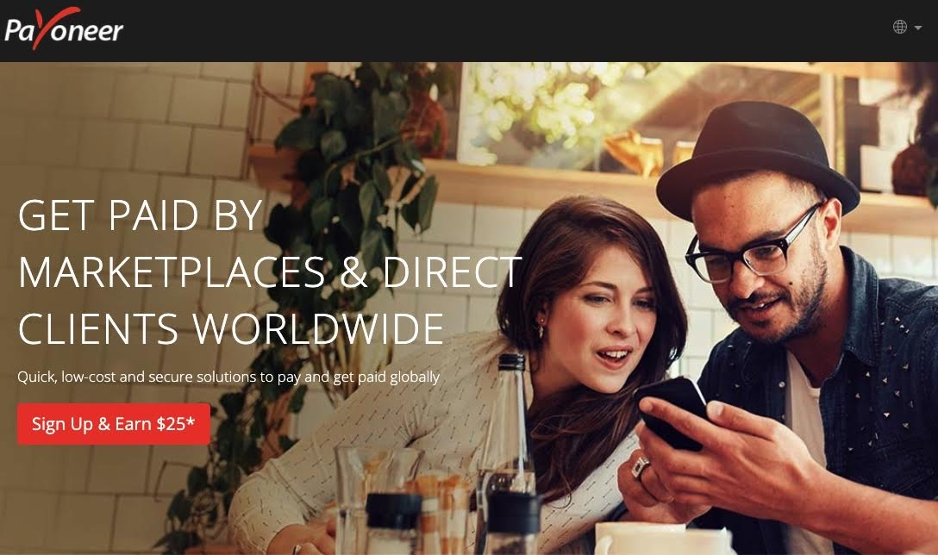

[](http://www.facebook.com/)Advertising Social Media

[Facebook](http://www.facebook.com/)

[Facebook](http://www.facebook.com/) operates as an online social networking platform that enables people to connect, share, discover and communicate with each other.  
  
Facebook's headquarters is in Menlo Park, California. Facebook has a revenue of $70.7B, and 35,587 employees. Facebook has raised a total of $31.8B in funding. Facebook has acquired 70 companies, with the most recent being Plessey Semiconductors Limited for an undisclosed amount on Mar 2020. As of August 2019, Facebook has 214.5M fans on Facebook and 14.0M followers on Twitter

Annual revenue: US$ 70.7 billion

Employees: 35587

Sector: Internet Software, Application Software

C0-Founder & CEOMark Zuckerberg

Owler CEO Approval Ranking:72/100

Founded: 20104 in Menlo Park/California

Ticker: FB

Bourse: NYSE

Website: [www.facebook.com](http://www.facebook.com/)



[](http://www.instagram.com/)Advertising Social Media.

[Instagram](http://www.instagram.com/)

[Instagram](http://www.instagram.com/) is a social networking application that allows users to capture, discover and share pictures and videos.  
  
Instagram is headquartered in San Francisco, California. Instagram has been a Subsidiary of Facebook, Inc. since Apr 2012. Instagram has received funding from investors such as Sequoia Capital, Thrive Capital, and Greylock Partners. Instagram's main competitors are Twitter, Snap and Pinterest. As of August 2019, Instagram has 60.2M fans on Facebook and 39.6M followers on Twitter.

Annual revenue: US$ 6.8 billion

Employees: 5275

Sector: Internet Software, Application Software

CEO: Adam Mosseri

Owler CEO Approval Ranking:85/100

Founded: 2010 in San Francisco/California

Private Company, Subsidiary of Facebook, Inc.

Website: www.[instagram](http://www.instagram.com/).com

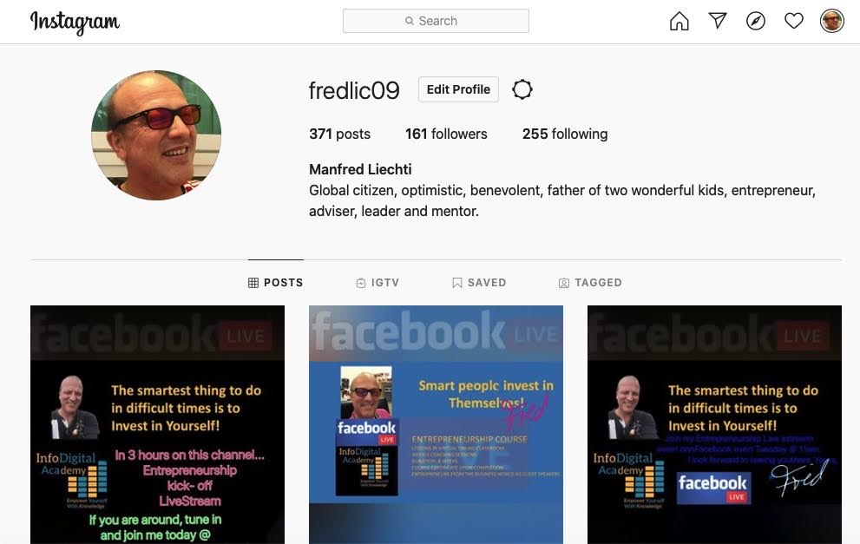

[](http://www.twitter.com/)Advertising Social Media

[Twitter](http://www.twitter.com/)

[Twitter](http://www.twitter.com/) is an online social network that enables real-time conversation and connects its users to people, information and news.  
  
Twitter's headquarters is in San Francisco, California. Twitter has a revenue of $3.5B, and 3,920 employees. Twitter's IPO generated $1.8B. Twitter has acquired 43 companies, with the most recent being Chroma Labs, Inc., for an undisclosed amount on Feb 2020. As of February 2020, Twitter has 15.9M fans on Facebook and 61.7M followers on Twitter.

Annual revenue: US$ 3.5 billion

Employees: 3920

Sector: Internet Software, Application Software

Co-Founder & CEO: Jack Dorsey

Owler CEO Approval Ranking:84/100

Founded: 2006 in San Francisco/California

Ticker: TWTR

Bourse: NYSE

Website: www.[twitter](http://www.twitter.com/).com

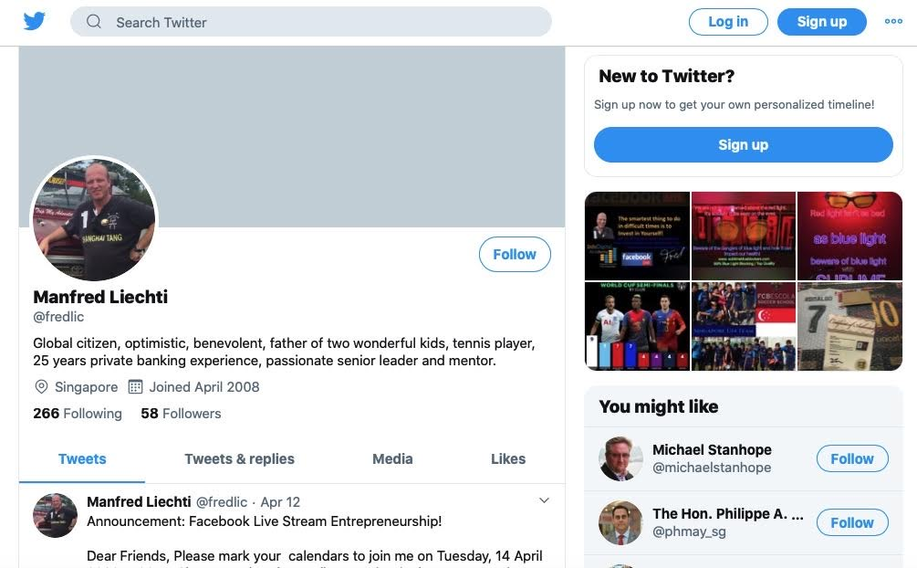

[](http://www.linkedin.com/)Advertising Social Media.

[LinkedIn](http://www.linkedin.com/)

[LinkedIn](http://www.linkedin.com/) is a professional networking site that allows its members to create business connections, search for jobs and find potential clients.  
  
LinkedIn's headquarters is in Sunnyvale, California. Jeff Weiner is the CEO of LinkedIn. LinkedIn has raised a total of $693.6M in funding. LinkedIn has acquired 19 companies, with the most recent being Drawbridge Inc. for an undisclosed amount on May 2019. As of February 2020, LinkedIn has 2.2M fans on Facebook and 1.4M followers on Twitter.

Annual revenue: US$ 7.5 billion

Employees: 16000

Sector: Internet Software, Application Software

Co-Founder & CEO: Jeff Weiner

Owler CEO Approval Ranking:75/100

Founded: 2003 in Sunnyvale/California

Private Company, Subsidiary of Microsoft

Wwbsite: [www.linkedin.com](http://www.linkedin.com/)

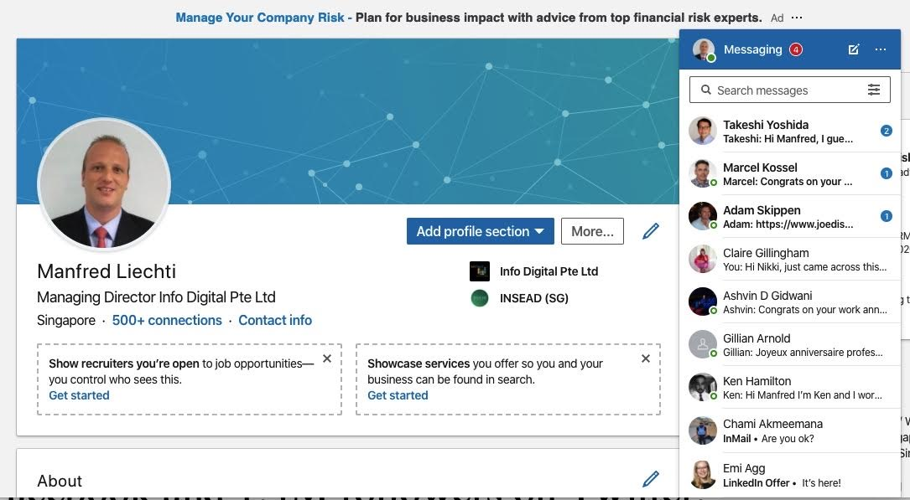

[](http://www.pinterest.com/)Advertising Sccial Media

[Pinterest](http://www.pintreresr,com/)

[Pinterest](http://www.pinterest.com/) is an online content discovery platform that allows users to share, sort and save media content.  
  
Pinterest is headquartered in San Francisco, California. Ben Silbermann is the Co-Founder & CEO of Pinterest. Pinterest has received a total of $2.8B in funding. Pinterest has acquired 14 companies, with the most recent being Jelly Industries, Inc for an undisclosed amount on Mar 2017. As of February 2020, Pinterest has 7.3M fans on Facebook and 2.4M followers on Twitter.

Annual revenue: US$ 1.1 billion

Employees: 2217

Sector: Internet Software, Application Software

Co-Founder & CEO: Ben Silbermann

Owler CEO Approval Ranking:81/100

Founded: 2009 in San Francisco/California

Ticker: PINS

Bourse: NYSE

Website: [www.pinterest.com](http://www.pinterest.com)

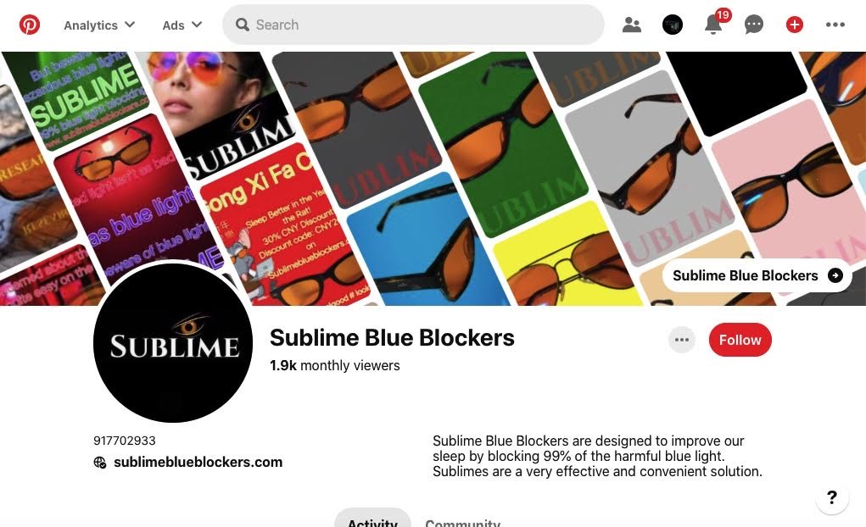

[](http://www.carousell.com/)

Advertising Social Media/Marketplace

[Carousell](http://www.carousell.com/)

[Carousell](http://www.carousell.com/) is an online marketplace that allows users to buy and sell clothes, beauty products, furniture, books and bikes.  
  
Carousell's headquarters is in Singapore, Central Singapore. Carousell has a revenue of $5M, and 400 employees. Carousell has raised a total of $232.8M in funding. Carousell's main competitors are Letgo, Depop and Swapit. As of August 2019, Carousell has 587.4K fans on Facebook and 13.9K followers on Twitter

Annual revenue: US$ 5 million

Employees: 400

Sector: Online Marketplace

Co-Founder & CEO: Siu Rui Quek

Owler CEO Approval Ranking: 79/100

Founded: 2129 in Singapore

Private Company

[](http://www.statista.com/)Knowledge & Research.

[Ststista](http://www.ststista.con/)

[Statista](http://www,statista.com/) is an online statistics portal that provides access to data from market and opinion research institutions.  
  
Statista's headquarters is in Hamburg, Hamburg. Statista has a revenue of $56.8M, and 600 employees. Statista's main competitors are [Statistics.com](http://www.statistics.com/) and [Reportlinker](http://www.reportlinker.com/). As of August 2019, Statista has 40.2K fans on Facebook and 36.8K followers on Twitter.

Annual revenue: US$ 56.8 million

Employees: 600

Sector: Business Data, Research

CEO: Friedrich Schwandt

Owler CEO Approval Rating: 64/100

Founded: 2007 in Hamburg/Germany

Private Company

Website: [www.statista.com](http://www.statista.com/)

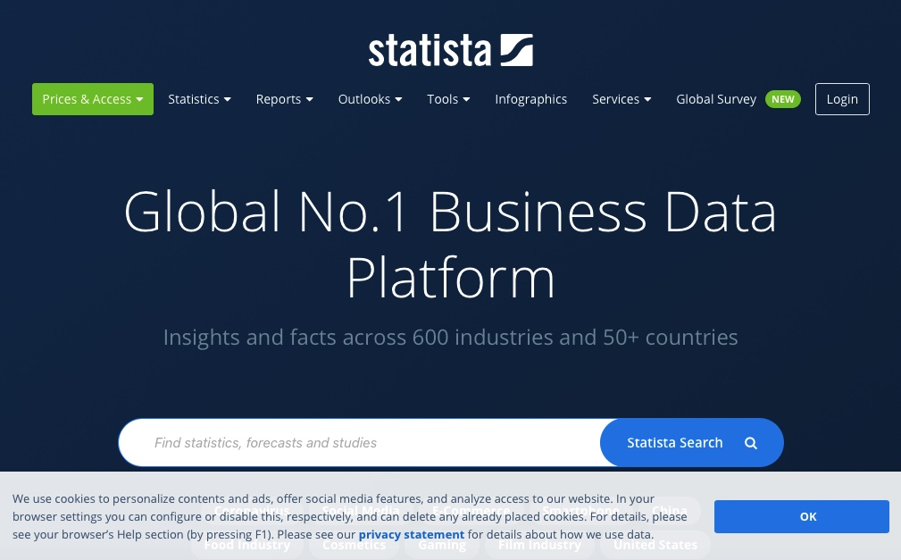

[](https://affiliate-program.amazon.com/)Affiliate Network

[Amazon Associates](https://affiliate-program.amazon.com/)

[The Amazon Associates Program](https://affiliate-program.amazon.com/) is one of the largest affiliate networks in the world that helps content creators, publishers, and website owners monetize their traffic. With millions of products to choose from on Amazon.com, Amazon Associates use easy link-building tools to direct their readers to products and earn from qualifying purchases. Not only do Associates earn commission on products they refer traffic to, they may also earn on other products their readers may purchase on Amazon. As an associate, you'll have full access to a suite of reporting tools to help you learn what resonates best with your readers.

You may need your own Amazon account to use certain Amazon Services, and you may be required to be logged in to the account and have a valid payment method associated with it. If there is a problem charging your selected payment method, we may charge any other valid payment method associated with your account. Visit https://www.amazon.com/cpe/managepaymentmethods?ref_=ya_d_c_pmt_mpo& to manage your payment options. You are responsible for maintaining the confidentiality of your account and password and for restricting access to your account, and you agree to accept responsibility for all activities that occur under your account or password. Amazon does sell products for children, but it sells them to adults, who can purchase with a credit card or other permitted payment method. If you are under 18, you may use the Amazon Services only with involvement of a parent or guardian. Parents and guardians may create profiles for teenagers in their Amazon Household. Alcohol listings on Amazon are intended for adults. You must be at least 21 years of age to purchase alcohol, or use any site functionality related to alcohol. Amazon reserves the right to refuse service, terminate accounts, terminate your rights to use Amazon Services, remove or edit content, or cancel orders in its sole discretion.

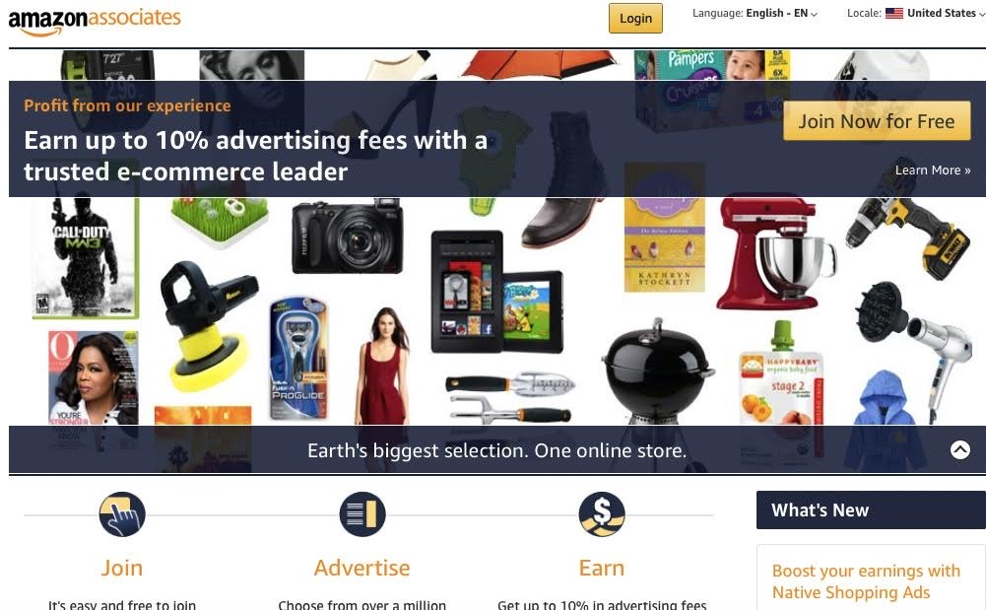

Pricing: Joining Amazon Associates is free,but Amsazin requires three quasifying purchases through you affiliate link within 180 days, faili8ng which they will close your Amazon Assoviates account.

Website

[](http://www.clickbank.com/)Affiliate Network

[Clickank](http://www.clickbank.com/)

[ClickBank](http://www.clickbank.com/) is an online marketplace that allows users to buy and sell digital products such as ebooks, software and videos.  
  
[ClickBank](http://www.clickbank.com/) is a Private company. Kelly Householder is the CEO of ClickBank and has an approval rating of 74 from Owler members. ClickBank's top competitor is CJ Affiliate, led by Waleed Al-Atraqchi, who is their President. ClickBank has 803 followers on [Owler](https://www.owler.com/company/clickbank)

Annual revenue: US$ 201.6 million

Employees: 347

Sector: Internet Software, Application Software

Co-Founder & CEO: Kelly Householder

Owler CEO Approval Ranking:74/100

Founded: 1998 in Boise/Idaho

Private Company, Subsidiary of Keynetic’s Inc.

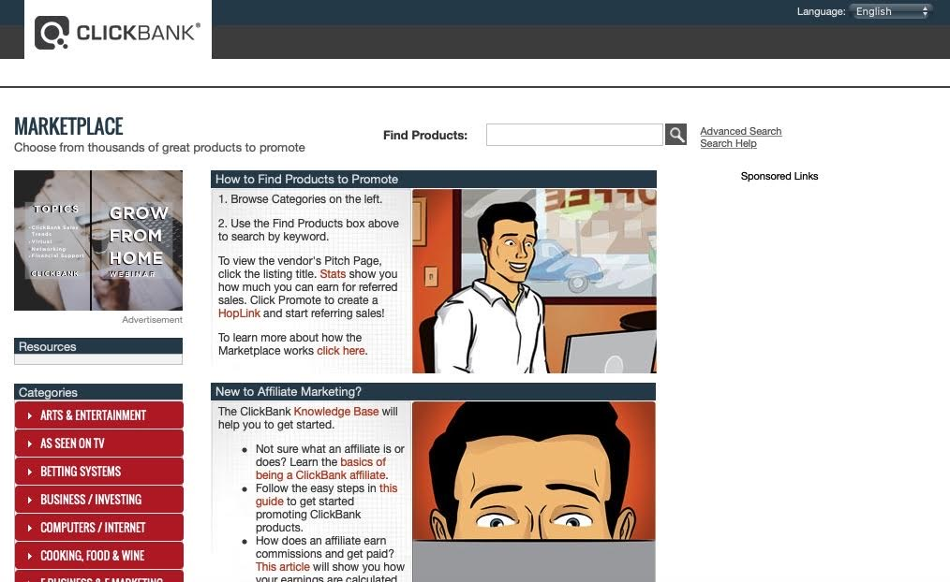

[](http://www.jvzoo.com/)Affiliate Network

[JV Zoo](http://www.jvzoo.com/)

[JV Zoo](http://www.jvzoo.com/) develops SaaS-based online sales and marketing solutions for businesses. JV Zoo is headquartered in Ovideo/Florida. Laura Casselman is the CEO of JV Zoo; JV Zoo’s main competitors are [Clickbank](http://www.clickbank.com/), [CJ Affiliate](https://www.cj.com/) and [ClickSure](http://www.clicksure.com/). As of August 2019 JV Zoo has 31.8k fans on Facebook and 179k followers on Twitter.

Annual revenue: US$ 7.4 million

Employees: 17

Sector: Advertising & Marketing

CEO: Laura Casselman

Owler CEO Approval Ranking: 88/100

Founded: 2011 in Ovideo/Florida

Private Company

Website: [www.jvzoo.com](http://www.jvzoo.com)

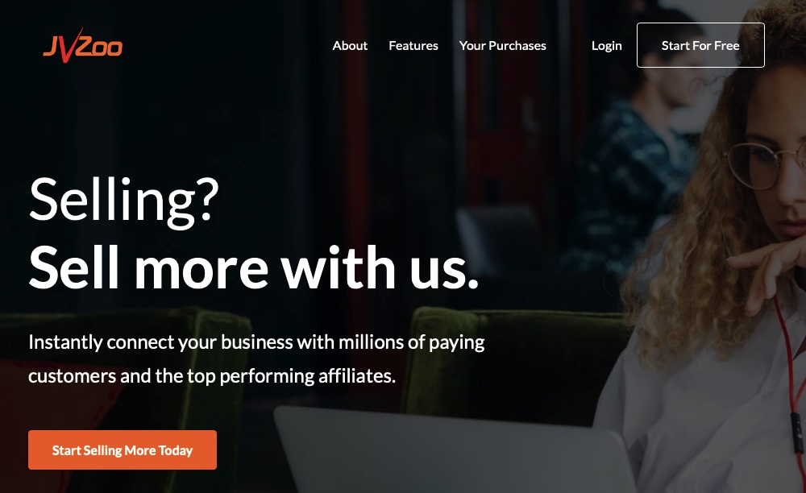

**EmailMarketingServices/Autoresponder**

AWeber.

AWeber helps businesses, entrepreneurs and bloggers increase sales and profits through its suite of web-based email marketing software.  
  
AWeber is a Private company. Tom Kulzer is the Founder & CEO of AWeber and has an approval rating of 77 from Owler members. AWeber's top competitor is ActiveCampaign, led by Jason VandeBoom, who is their Founder & CEO. AWeber has 3,791 followers on Owler.

AWeber develops and runs an opt-in email marketing service used by over 120,000 small businesses, bloggers and entrepreneurs around the globe. Their web-based tools help businesses grow by staying in touch with customer and prospects through email.

Annual revenue: US$ 17.2 million

Employees 134

Sector: IT Services/Internet Software

GFounder & CEO: Tom Kulzer

Owler CEO Approval Ranking 77/100

Founded: 1998 in Chalfont/Pennsylvania

Private Company

Website: [www.aweber.com](http://www.aweber.com)

**[](http://www.getreswponse.com/)**

**EmailMarketingServices/Autoresponder**

[GetResponse](http://www.getresponse.com/)

[GetResponse](http://www.getresponse.com/) is a marketing platform that offers email marketing, online campaign management, marketing automation and customer management services.  
  
GetResponse's headquarters is in Gdansk, Pomerania. GetResponse has a revenue of $50M, and 250 employees. GetResponse's main competitors are SendinBlue, Convertkit and Campaign Monitor. As of February 2020, GetResponse has 145.5K fans on Facebook and 67.2K followers on Twitter.

Annual revenue: US$ 50,02 million

Employees 250

Sector: Marketing Serrvices

GFounder & CEO: Simo. Grabowski

Owler CEO Approval Ranking 54/100

Founded: 1998 in Gdansk/Poland

Private Company

Website: [www.gewtresponse.com](http://www.gertresponse.com/)

**[](https://mailchimp.com/)**

**EmailMarketingServices/Autoresponder**

[Mailchimp](https://mailchimp.com/)

[Mailchimp](https://mailchimp.com/) is an American marketing automation platform and an email marketing service. The platform is a trading name of its operator, Rocket Science Group, an American company founded in 2001 by Ben Chestnut and Mark Armstrong, with Dan Kurzius joining at a later date.

Pricing depends on your sending activities anf your list size.

List: Price:

<2000 Free

5,000 S$168.00

10,000 S4102.00

20,000 S$205.00

Mailchimp is a good provider to start off with, but once the business grows and you may requiremore sophisticated functionality, people often switch to AWeber or GetResponse, or at least add one of these oroviders to their business.

Info Digital Group started off with Mailchimp, which seemed to work well., at least at the beginning. Over time, as our businesses evolved , Maiulchimp became a bit difficult to work with and blocked our account for no apparent reason (which is then usually followed by long and ,detailed follow ups with their compliance, which we deemed as too time consuming so we switxhed to the other two mentioned providers, which both appear more sophisticated with their offering. But again, for beginners and newcomers Mailchimp seems the best option .

**[](https://www.surveymonkey.com/)Survey’s & Questionnaires**

[**Survey Monkey**](http://www.surveymonkey.com/)

[SurveyMonkey](https://www.surveymonkey.com/) is a cloud-based online survey and questionnaire platform that helps users to gather survey-related information.  
  
SurveyMonkey's headquarters is located in San Mateo, California. SurveyMonkey generates $358.7K in revenue per employee SurveyMonkey's investors include T. Rowe Price, Morgan Stanley Investment Management, and Baillie Gifford. SurveyMonkey's top competitor is Typeform, led by Joaquim Lecha, who is their CEO. SurveyMonkey has 6,364 followers on Owler.

Annual revenue: US$ 307.4 million

Employees 857

Sector:

Internet Sotware / Application Software

CEO: Zander Lurie

Owler CEO Approval Ranking 82/100

Founded: 1999 in San

Mateo//XCalifornia

Ticker: SVMK

Bourse: Nasdaq

Website [www.surveymonkey.com](http://www.surveymonkey.com)

Survey Monkey offers four basic price plans: Premier Annual, Advantage Annual, Standard Monthly, and Flex.

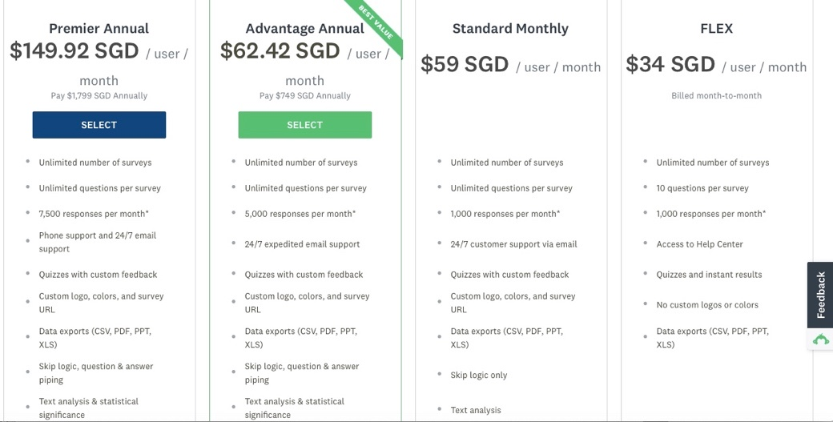

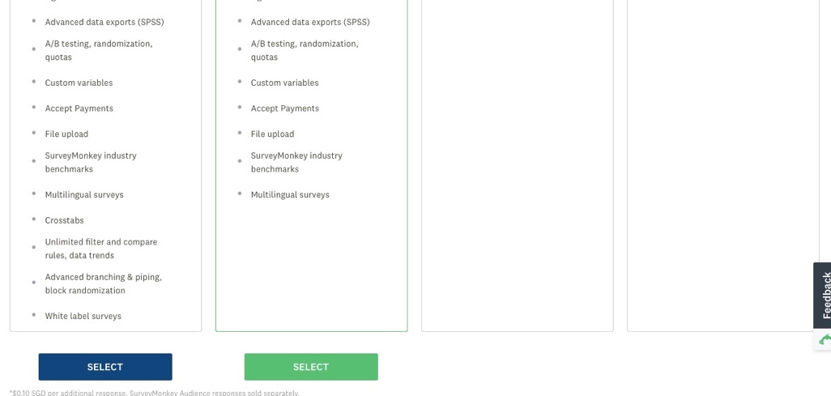

**[](https://corp.owler.com/)Company Research (crowd-sourced)**

[**Owler**](https://corp.owler.com/)

[Owler](https://corp.owler.com/) is a community-based competitive insights platform used to outsmart the competition and uncover competitive insights, news and alerts.  
  
Owler is a Private company. Tim Harsch is the Co-Founder & CEO of Owler and has an approval rating of 80 from Owler members. Owler has received a total of $23.9M in funding. Owler's top competitor is InsideView, led by Umberto Milletti, who is their Founder & CEO. Owler has 35,881 followers on Owler.

Basic access to Owler is free. There are paid upgrades available.

Annual revenue: US$ 3.2 million

Employees 93

Sector: Crowd-sourced Research

CVo-Founder % CEO: Tim Harsch

Owler CEO Approval Ranking 80/100

Founded: 2011 in San

Mateo//XCalifornia

Ticker: SVMK

Bourse: Nasdaq

[Website:](http://www.corp.owler.com/)



**[](http://www.stickermule.com/)Custom Labels & Stickers**

[Sticker Mule](http://www.stickermule.com/)

Sticker Mule produces Labels and packaging for food, beverages, medical and essential services support . Free proofs, free shipping, fast turnaround and 24/7 customer support.Stiucker Mule is located in AmsterdamHolland.

[Website](http://www.stickermule.com/)

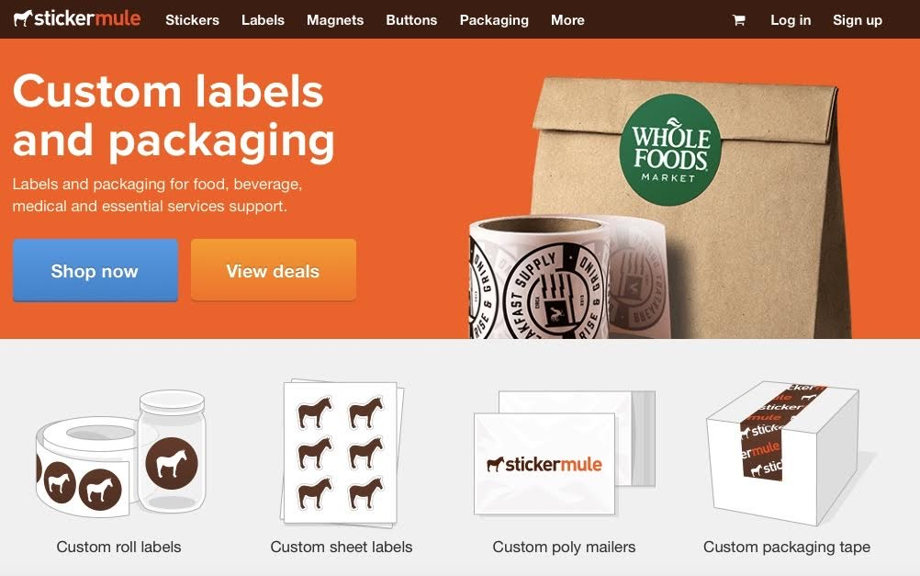

**[](http://www.vistaprint.com/)**

**Stationary & Marketing Material**

[Vistaprint](http://www.vistaprint.com/)

[Vistaprint](http://www.vistaprint.com/) is an online supplier of printed marketing materials, signage and photo products.  
  
Vistaprint is headquartered in Venlo, Other. Robert Keane is the CEO of Vistaprint. Vistaprint's main competitors are Canvera, Printvenue and Zazzle. As of August 2019, Vistaprint has 60 fans on Facebook and 53.6K followers on Twitter.

Annual revenue: US$ 2.7 billion

Employees 3,600

Sector: Printed Marketing Materials

CEO: Robert Keane

Owler CEO Approval Ranking 70/100

Founded: 1995

Private company, subsidiary of Cimpress (CMPR/NASDAQ)

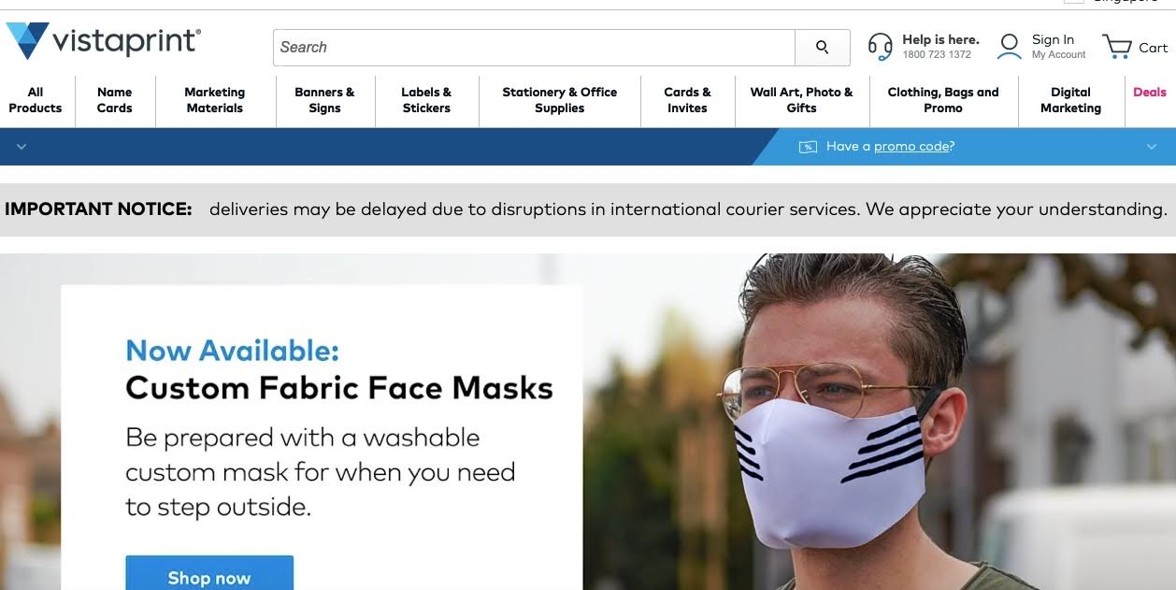

Website: [www.vistaprint.com](http://www.vistaprint.com)

[](http://www.alibaba.com/)

**Ecommerce Suppliers**

[Alibaba](http://www.alibaba.com/)

[Alibaba](http://www.alibsaba.com/) Group Holding Limited is a Chinese multinational technology company specializing in e-commerce, retail, Internet, and technology

Annual revenue: CNY 376.8 billion

Employees 101,958

Sector: Ecommerce TAechnology

CEO: Daniel Zhang

Owler n.a.

Founded: 1988 in Hangzhou/Cina

Ticker:BABA

Bourse: NYSE, SEHK

[Website](http://www.alibaba.com/)

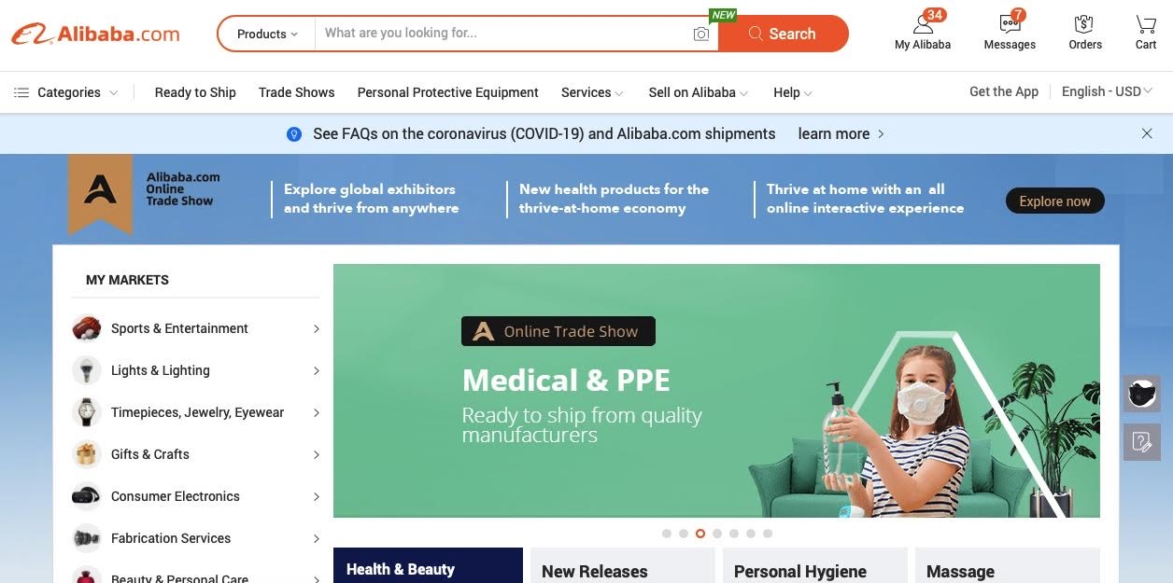

[](http://www.mangools.com/#a599fe6d4285f737d8d22a11b)

SEO Tools

[Mangools](http://www.mangools.com/#a599fe6d4285f737d8d22a11b)

[**Mangools**](http://www.mangools.com/#a599fe6d4285f737d8d22a11b)is a bundle of 5 simple but powerful SEO tools made for an effective SEO workflow. Loved by beginners, trusted by professionals. Try it for free!

Backlink Analysis

Website Analysis

Keyword Research

SERP Analysis

Rank Tracking

You can start using Mangools for free. Paid upgrades are available.

[Website](http://www.mangools.com/#a599fe6d4285f737d8d22a11b)

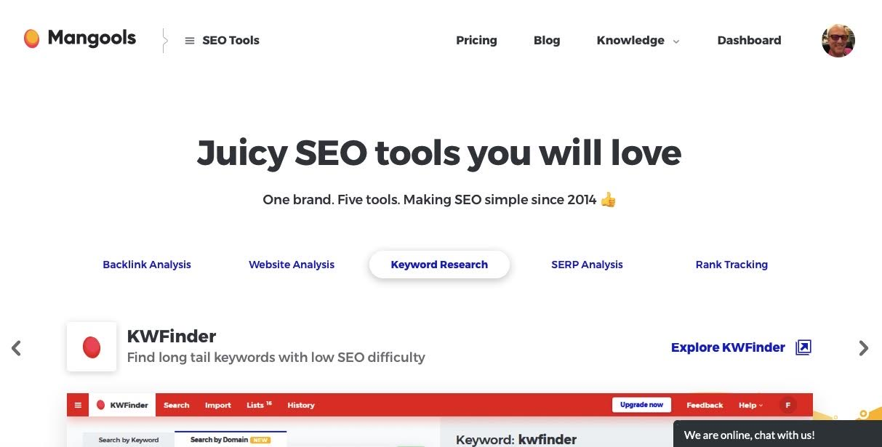

[](http://www.shopify.com/)

ECommerce Platform

[Shopify](http://www.shopify.com/)

[Shopify](http://www.shopify.com/) Inc. is a Canadian multinational e-commerce company headquartered in Ottawa, Ontario. It is also the name of its proprietary E-Commerce platform for online stores and retail point-of-sale systems.

Shopify provides a cloud-based, multi-channel e-commerce solutions for small and medium-sized businesses.  
  
Shopify is headquartered in Ottawa, Ontario. Tobias Lutke is the Co-Founder & CEO of Shopify. Shopify's IPO generated $130.9M. Shopify's main competitors are Magento, BigCommerce and WooCommerce. As of February 2020, Shopify has 3.5M fans on Facebook and 228.2K followers on Twitter.

[Website](http://www.shopify.com/)

Annual revenue: US$1.48 billion

Employees 1,500

Sector: Ecommerce Solutions / Application Software

Co-Founder & CEO: Tobias Lutke

Owler CEO Approval Rating: 67/100

Founded: 2004in Ontario/Canada

Ticker: SHOP

Bourse: NYSE

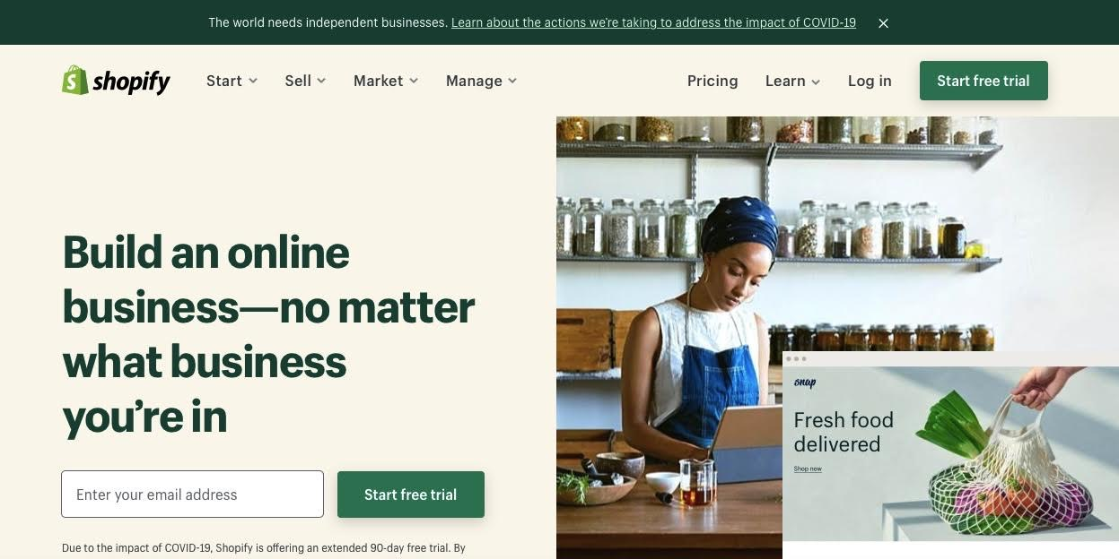

Info Digital Group uses Shopify for their online store [www.sublimeblueblockers.com](http://www.sublimeblueblockers.com)



Online Course Platform

[Thinkific](http://try.thinkific.com/manfredliechti3827)

[Thinkific](http://try.thinkific.com/manfredliechti3827) is a provider of online learning tools that allows users to create a course, promote it and earn money from student tuition charges.  
  
Thinkific's headquarters is in Vancouver, British Columbia. Thinkific has a revenue of $15M, and 100 employees. Thinkific's main competitors are Teachable, Ruzuku and Click 4 Course. As of August 2019, Thinkific has 20.7K fans on Facebook and 4.6K followers on Twitter.

Annual revenue: US$ 15 million

Employees 100

SectorEducational Software

Co-Founder & CEOGreg Smith

Owler CEO Approval Rating: 84/100

Founded: 2012 in Vancouver/Canada

Private Company

You can start with Thinkific for free. Paid upgrades available.

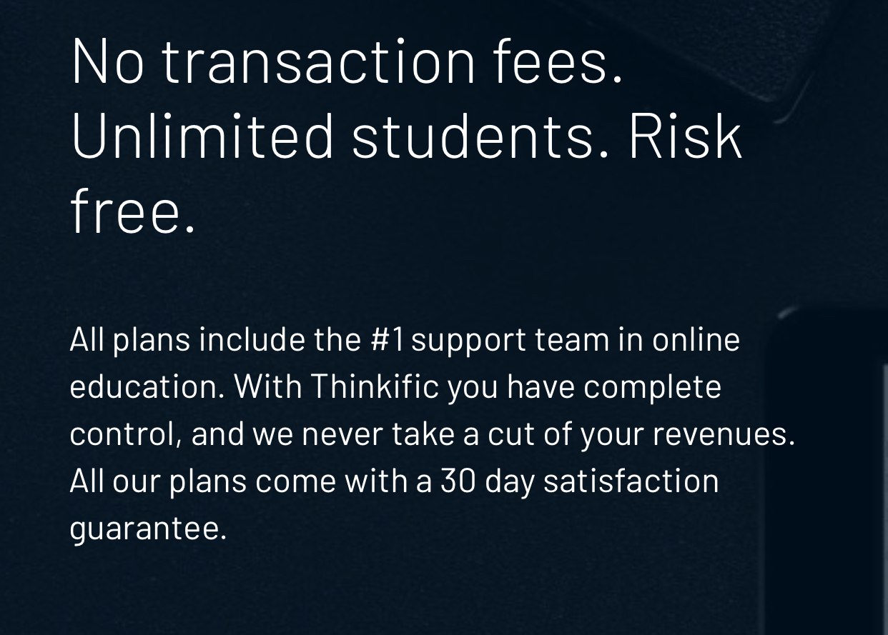

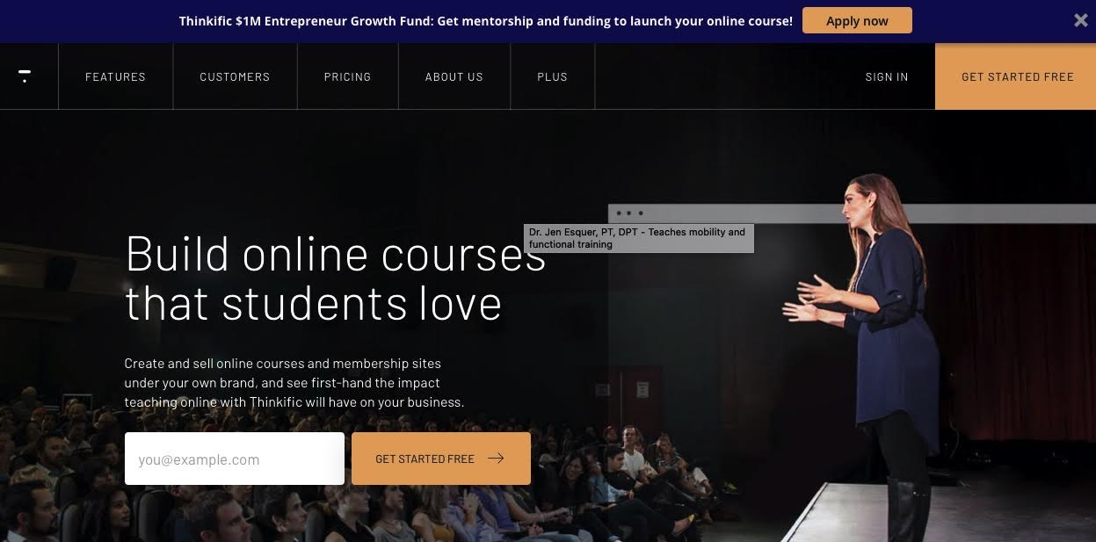

[Website](http://www.thinkific.com/)

I hope this Guide provides you with some useful information.

To Your Success!





Disclaimer:

Info Digital Academy, as past of the Info Digital Group, on occasions acts as affiliate for other product or solutions providers. Anything that is reviewed and recommended on our websites or in our publicatios is based on our own review, and on the rare occasion, the review of our trusted peers.We work hard to do our own due diligence before recommending any product or service, so that our clients are getting the best advice. Occasionally, we may receive a commission whern recommending certain products and services, but our recommendations are not influenced by any potential affiliate commissions, but aleways based on what we believe to be best advice. We aim for our clients yo make informed decision and recommend they also do their own due diligence before making a purchase.